**MATH 205 – Calculus I SQ 2.2**

Name: ________________ Date: _______

**To receive any credit for the following problems, you must show complete and accurate work. Use proper limit notation and give exact answers unless otherwise noted.**

Given the graph of *f*(*x*) below, determine the following limits:

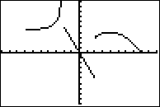

1.  2. 

3.  4. 

5.  6. 

7. 8.

9. 10.